**Lab # 8**

Name: Mukand Krishna Roll no: 20k-0409

**Task#1**

Octal to Binary Priority Encode

Truth Table

|  |  |  |  |  |  |  |  |  |  |  |
| --- | --- | --- | --- | --- | --- | --- | --- | --- | --- | --- |
| D 7 | D 6 | D 5 | D 4 | D 3 | D 2 | D1 | D 0 | Z 2 | Z 1 | Z 0 |
| 0 | 0 | 0 | 0 | 0 | 0 | 0 | 1 | 0 | 0 | 0 |
| 0 | 0 | 0 | 0 | 0 | 0 | 1 | X | 0 | 0 | 1 |
| 0 | 0 | 0 | 0 | 0 | 1 | X | X | 0 | 1 | 0 |
| 0 | 0 | 0 | 0 | 1 | 1 | X | X | 0 | 1 | 1 |
| 0 | 0 | 0 | 1 | X | X | X | X | 1 | 0 | 0 |
| 0 | 0 | 1 | X | X | X | X | X | 1 | 0 | 1 |
| 0 | 1 | X | X | X | X | X | X | 1 | 1 | 0 |
| 1 | X | X | X | X | X | X | X | 1 | 1 | 1 |

I n p u t

**Output**

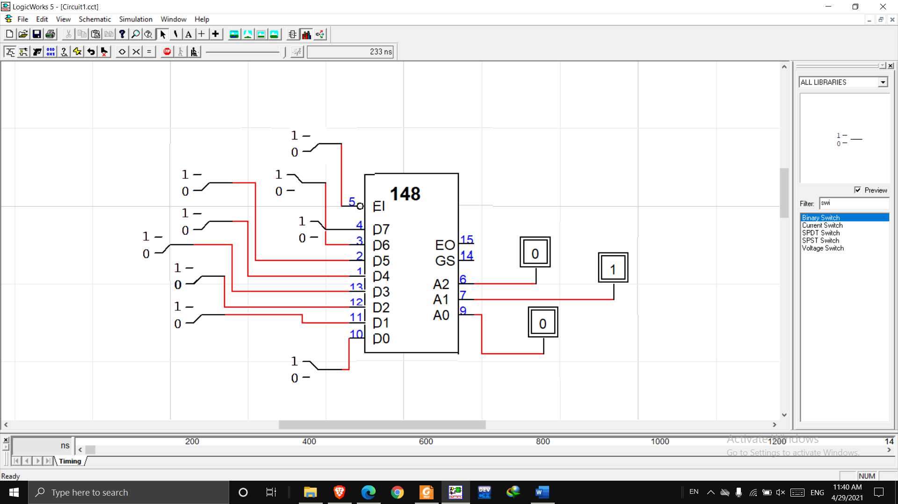

Circuit Diagram

**Task#2**

Decimal to BCD Priority Encoder

Truth Table

|  |  |  |  |  |  |  |  |  |  |  |  |  |  |
| --- | --- | --- | --- | --- | --- | --- | --- | --- | --- | --- | --- | --- | --- |
| **E~** | **1~** | **2~** | **3~** | **4~** | **5~** | **6~** | **7~** | **8~** | **9~** | **Q3~** | **Q2~** | **Q1~** | **Q0~** |
| 0 | 0 | 0 | 0 | 0 | 0 | 0 | 0 | 0 | 0 | 0 | 0 | 0 | 0 |
| X | X | X | X | X | X | X | X | X | 1 | 1 | 0 | 0 | 1 |
| X | X | X | X | X | X | 0 | 0 | 1 | 0 | 1 | 0 | 0 | 0 |
| X | X | X | X | X | X | X | 1 | 0 | 0 | 0 | 1 | 1 | 1 |
| X | X | X | X | X | X | 1 | 0 | 0 | 0 | 0 | 1 | 1 | 0 |
| X | X | X | X | X | 1 | 0 | 0 | 0 | 0 | 0 | 1 | 0 | 1 |
| X | X | X | X | 1 | 0 | 0 | 0 | 0 | 0 | 0 | 1 | 0 | 0 |
| X | X | X | 1 | 0 | 0 | 0 | 0 | 0 | 0 | 0 | 0 | 1 | 1 |
| X | X | 1 | 0 | 0 | 0 | 0 | 0 | 0 | 0 | 0 | 0 | 1 | 0 |
| 1 | 1 | 0 | 0 | 0 | 0 | 0 | 0 | 0 | 0 | 0 | 0 | 0 | 1 |

Circuit diagram

